Welcome to the first ever Revit Structure Tips and Tricks!

In these emails we will be sharing useful Revit Structure tools and features along with typical SGH Revit practices and standards. We will be covering topics for beginners as well as advanced users.

Our hope is not only to teach new skills, but to also keep everyone at SGH aware of what Revit Structure can do and what we are doing with it.

If you want more information on any Revit topic, have discovered a better way of doing things, have a Revit question, or have a “Tips and Tricks” request don’t hesitate to contact Katie Chapman.

* **Installing Revit Structure:** The first step in using the software is having it installed on your computer. We’ve created deployments for all our Revit Structure software versions that automatically set up our SGH standards and licensing information. All you have to do is run the application and click “Next” a few times. Below are the locations of all our Revit versions.
  + **Revit Structure 2011:** I:\BOS\Software\SE\Autodesk REVIT\64bit\Autodesk Revit 2011 “Revit Structure 2011 – x64”
  + **Revit Structure 2012:** I:\BOS\Software\SE\Autodesk REVIT\64bit\Autodesk Revit 2012 “Revit Structure 2012 – x64”
  + **Revit Structure 2013:** I:\BOS\Software\SE\Autodesk REVIT\64bit\Autodesk Revit 2013 “Revit Structure 2013 – x64”
  + **Revit 2014:** I:\BOS\Software\SE\Autodesk Bldg Suite\x64\2014\Revit “Revit 2014” (Beginning with the 2014 release Revit is no longer separated into different software packages for each discipline. Now Revit Structure, Architecture, and MEP are all combined into a single package simply called “Revit 2014”)
* **What the heck is a View Control Bar and where is the Project Browser?** In these upcoming Tips and Tricks emails I’ll be using some Revit terminology that may be new to you. Below is a map of where some of the important items in the Revit Structure user interface are located.

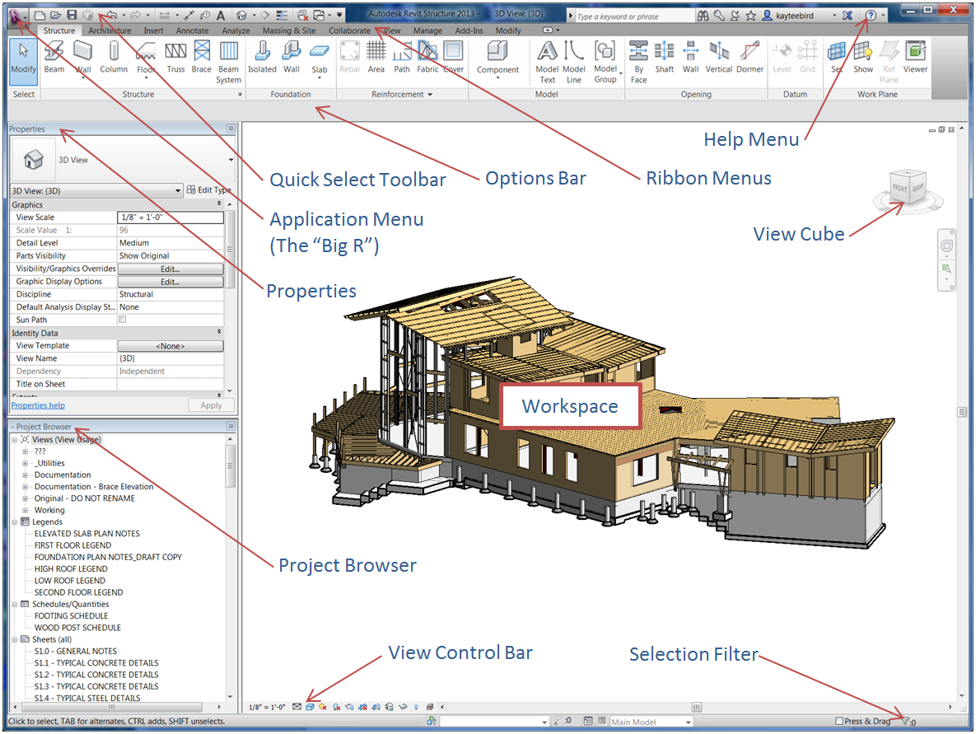

* **SGHNet Revit:** We have an SGHnet page dedicated to Revit! Check it out for instructions, standards, and other Revit news.

[SGHnet Revit](http://sghnet.sgh.com/Operations/Drafting/Revit/Pages/Default.aspx)

* **Dimensioning an Entire String of Grids at Once:** Did you know you can dimension and entire string of grids in just a few clicks? Once you have your grids laid out draw a wall perpendicular to the grids that intersects all the grids to be dimensioned. Activate the Aligned Dimension tool and change the Pick setting on the options bar from “Individual References” to “Entire Walls” and click the Options button. In Options check the box next to “Intersecting Grids”. Hover over the wall you’ve just created and pick. A dimension string dimensioning the ends of the wall and all intersecting grids will appear. Delete the wall and the dimensions between the grids will remain.



Dimensions Options Bar